WORK IN PROCESS REPORT

The J-R-12 work in process report shows the value of work in process by calculating the actual labor and actual material costs that have been posted to the job then subtracting the material and labor cost that have been received into finished goods. When adding a job, the cost per thousand is calculated from the estimate machine and material standards.

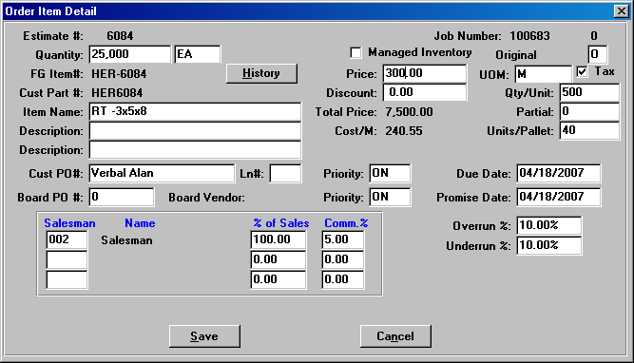

A look at the job file reveals the cost for material, direct labor and overheads per thousand. When finished goods are received, the finished goods material and labor costs are subtracted from the work in process costs posted. In this example, if we receive 5,000 boxes of the total job quantity 25,000 at the end of the month. Material costs of (5,000/1000 x $99.2342) = $495.12 will be subtracted from the work in process material costs. Direct Labor of (5,000/1000 x $47.5563 = $237.78) would also be subtracted from work in process.

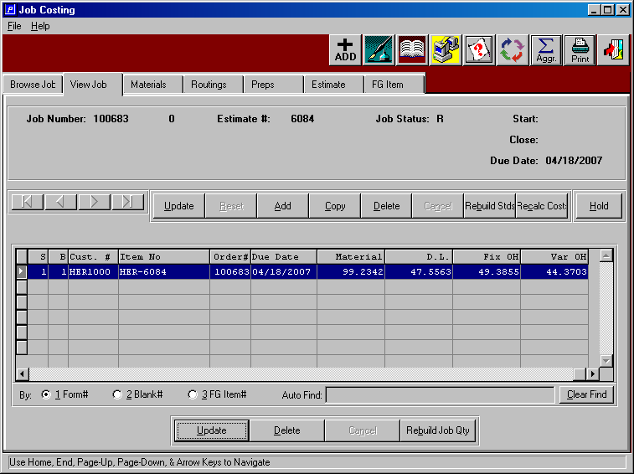

We will place a purchase order for board material at a cost of $1000 per ton.
Please note, the consumption unit of measure is the cost that the inventory is stocked. In this example, our unit of measure is lineal feet or LF, however we can stock per each sheet, ton, must and other units of measure. The important fact is that the value is in the consumption value and the job cost is transferred at the consumption cost unit of measure.

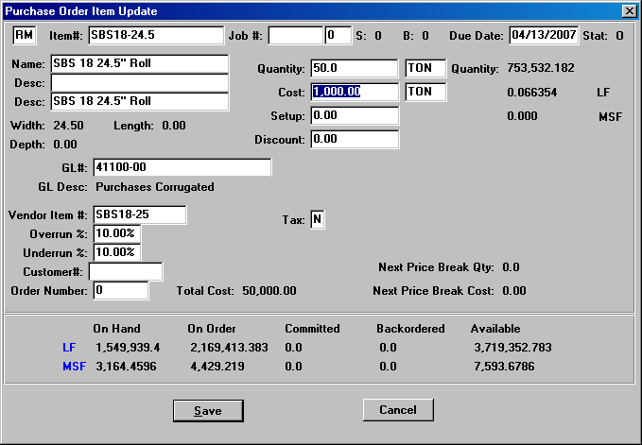

Receipts for this PO will show the stock keeping unit of measure.

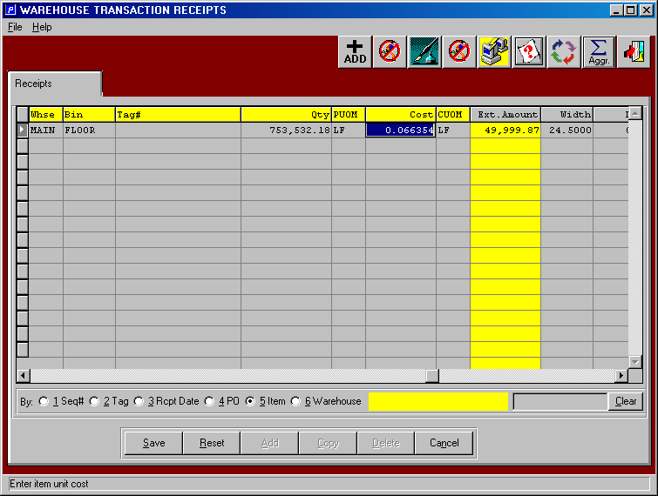

Whereas, issues to the job may be entered in sheets, however the cost is converted into the consumption unit of measure. As you see, I can enter 27,000 EA, however the system converts this to 77,062.50 LF, because 27,000 sheets times the jobs sheet length of 34.25 divided by 12 inches = 77,062.50 LF at a total work in process of $5,113.40

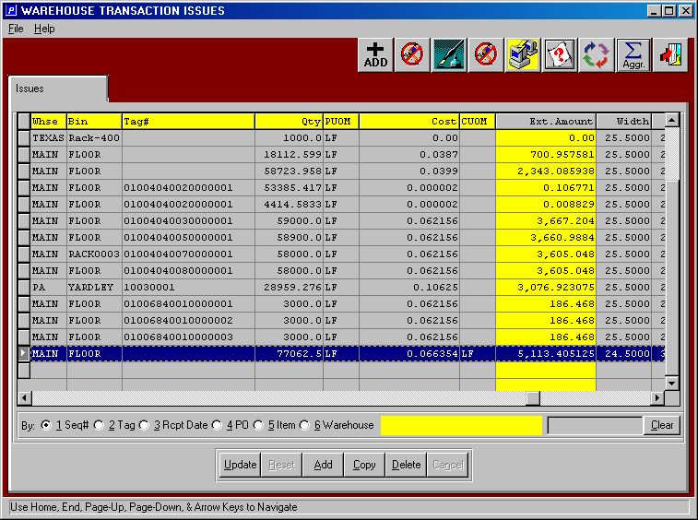

If we run the job’s work in process report after the board has been issued to the job, the J-R-12 report will reflect the actual material cost. In the example below, job 100383 has a total of $5,113.41 of material in work in process.

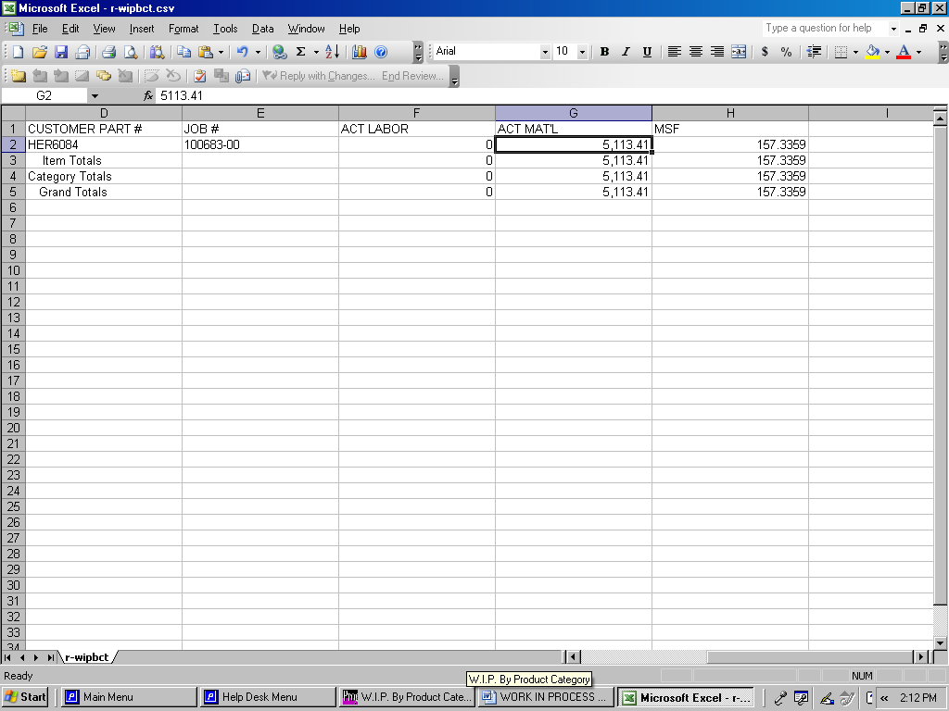

We can also review how the costs were calculated by reviewing the job query via J-Q or via the job transactions via J-F-1. The job inquiry will display the costs for material and labor. If we click the material folder, we can see the material cost. If you double click this line, while logged into as asi, the transactions will display.

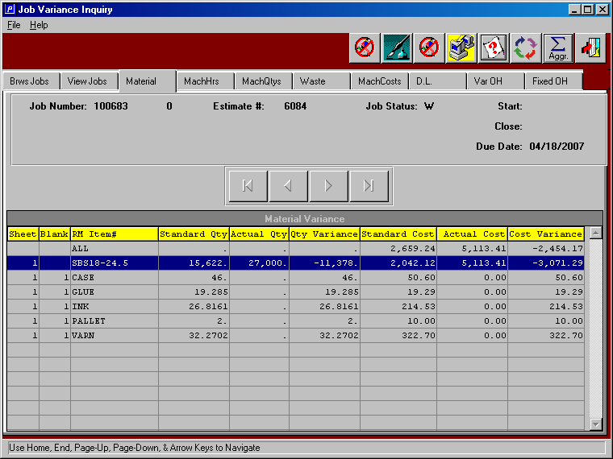

Likewise, we can post machine hours against the job to update the job cost and work in process costs. If we look at the job file, the routing folder shows the costs of each machine per hour that will be used to post to the job. In this case the 408 printing press has a direct labor cost of $50, fixed overhead of $100 and variable overhead of $100.

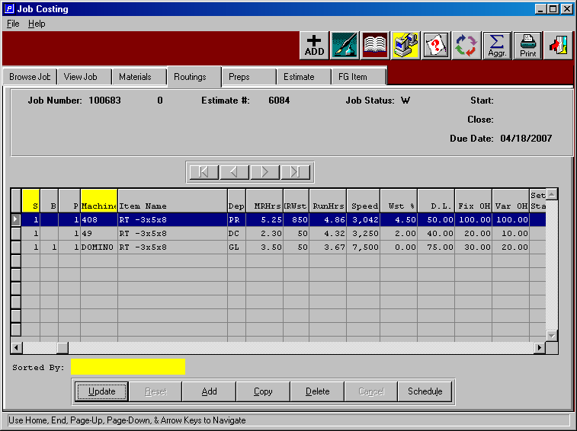

We will post 1 hour make ready and 3 hours of run hours to job 100683 for a total of 4 hours at a total machine rate of $250 toward the job cost and work in process.

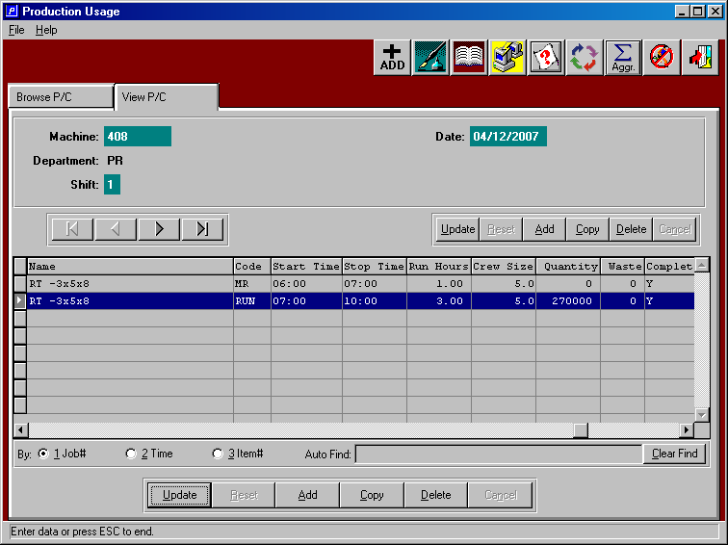

The work in process report via J-R-12 will now show the material and labor cost of work in process. The total machine rate of $250 per hour is multiplied by 1 hour of setup and 3 hours of run for a total cost of $1,000.

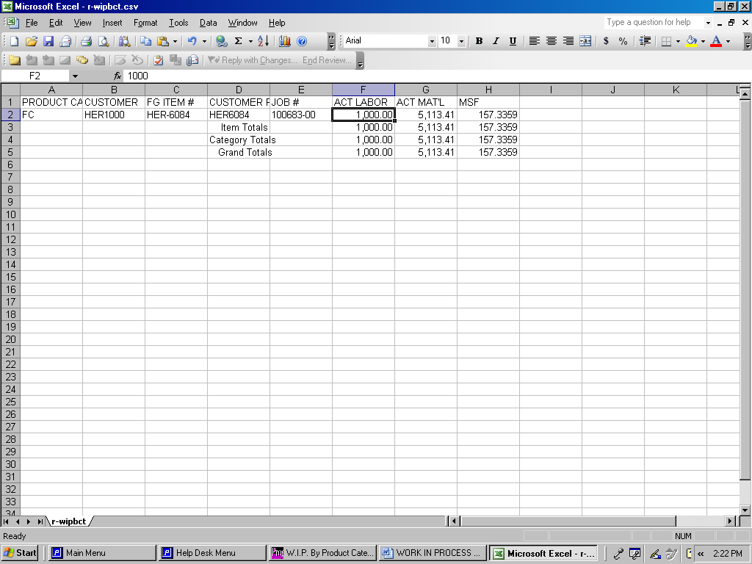

FG POST AUDIT TRAIL

DATE ITEM DESCRIPTION UNITS COUNT TOTAL BIN COST
4/12/07 HER-6084 RT -3x5x8 20 500 5,000 FLOOR $1,202.73

We will assume that we had run all the machine operations, however we only produced 5,000 boxes of the 25,000 job quantity. I will not post anymore machine costs to show the cost calculation with just one machine and board posted. The 5,000 / 1000 times the job standard material cost of 99.2342 equals $496.17, which is subtracted from the actual WIP cost.

The job file reveals the cost for material of $99.2342, therefore when finished goods are received, the finished goods material costs of $496.17 will be subtracted from the actual work in process material costs of $5,113.41 to yield a remaining WIP of $ 4,617.24. Likewise, the actual labor cost of $1000 for the printing press will also be reduced by $706.56 to yield a WIP value of $293.44.
Please note, the job cost is calculated by adding the per thousand cost of direct labor of $47.5563 plus fixed overhead of $49.3855 plus the variable overhead of $44.3703, which equals $ 141.31. This total labor cost is multiplied by the 5,000 boxes received and divided by 1000 since the standard costs are per thousand.

